Arrays

LAB # 05



Spring 2022

CSE-102L COMPUTER PROGRAMMING LAB

Submitted by: MUHAMMAD SADEEQ

Registration No.: 21PWCSE2028

Section: C

"On my honor, as student of University of Engineering and Technology, I have neither given nor received unauthorized assistance on this academic work.'

Student Signature: _____________________

Submitted to:

Engr. Abdullah Hamid

(July 2022)

Department of Computer Systems Engineering University of Engineering and Technology, Peshawar

# Lab 5: Arrays

## Objectives:

## To understand the programming knowledge using Array

To understand the programming using array

## Tasks:

1. Write a program in which you take your registration number and name as input into an array from the user and then output your registration number and name from the array. Use loops for input and output.
2. Write a program to input twelve numbers from user using array and display all values on console (3 values in a row) (use separate loops for input and output operation).

SAMPLE OUTPUT:

Value 1=?? Value 2=?? Value 3=??

Value 4=?? Value 5=?? Value 6=??

Value 7=?? Value 8=?? Value 9=??

Value 10=?? Value 11=?? Value 12=??

1. Write a program to input ten numbers from user using array and find the average of numbers (use separate loops for input operation and calculation).
2. Write a program to input multiple values from user using array and find the maximum (use separate loops for input operation and calculation).
3. Write a program to input two arrays from user and find the sum of arrays (element by element).
4. Write a program to input array from user and display the elements of array in reverse order (use separate loops for input and output operation).

SAMPLE OUTPUT:

Input = 1, 2, 3, 4, 5

Output = 5, 4, 3, 2, 1

1. Write a program to input multiple values from user using array and then ask user to input a key number and then compare it with values entered by user (for array) and then display the index number of array with which value get matched (use separate loops for input operation and calculation) (use different loops for input operation and calculation).

**COMPUTER PROGRAMMING LAB # 5**

**Answer #1**

**CODE:**

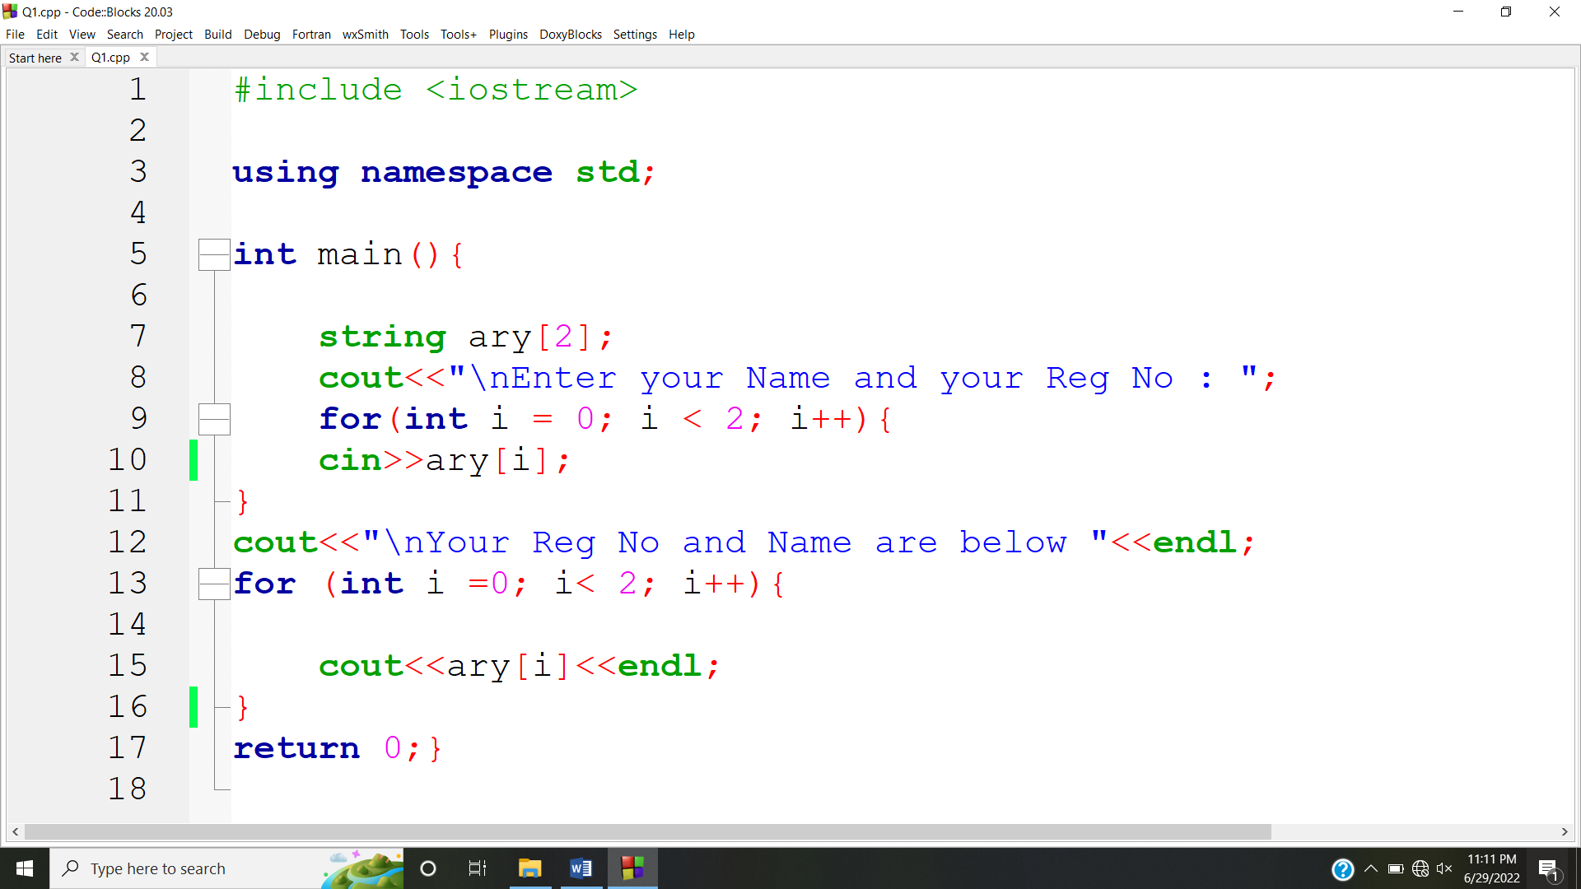

**OUTPUT:**

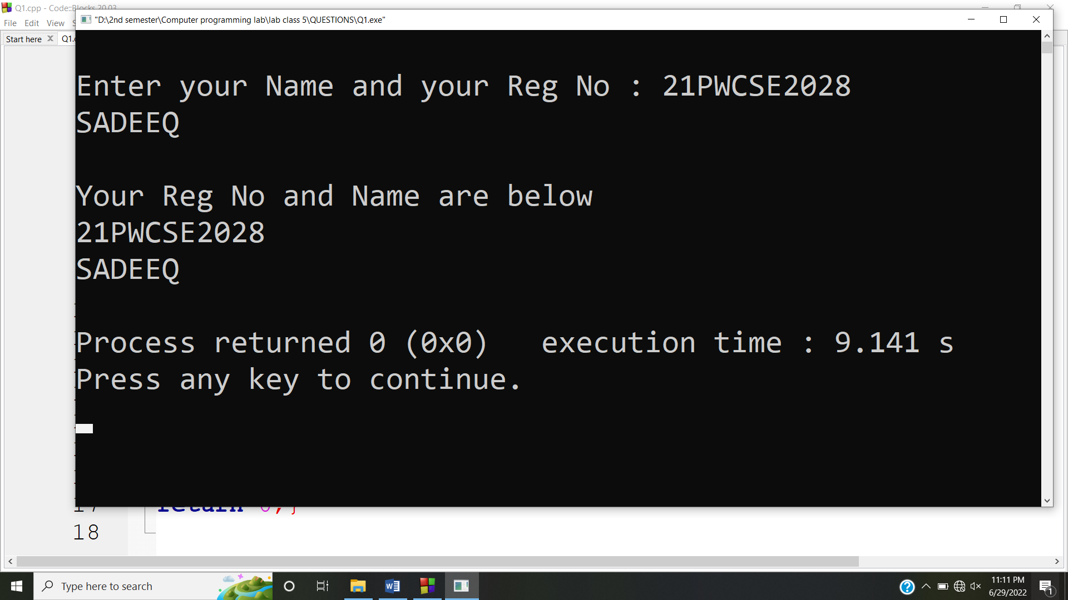

**Answer #2**

**CODE:**

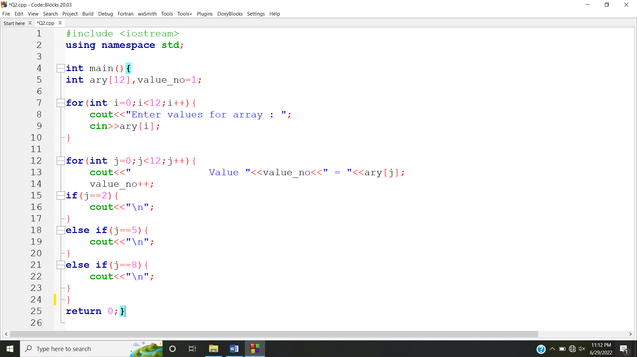

**OUTPUT:**

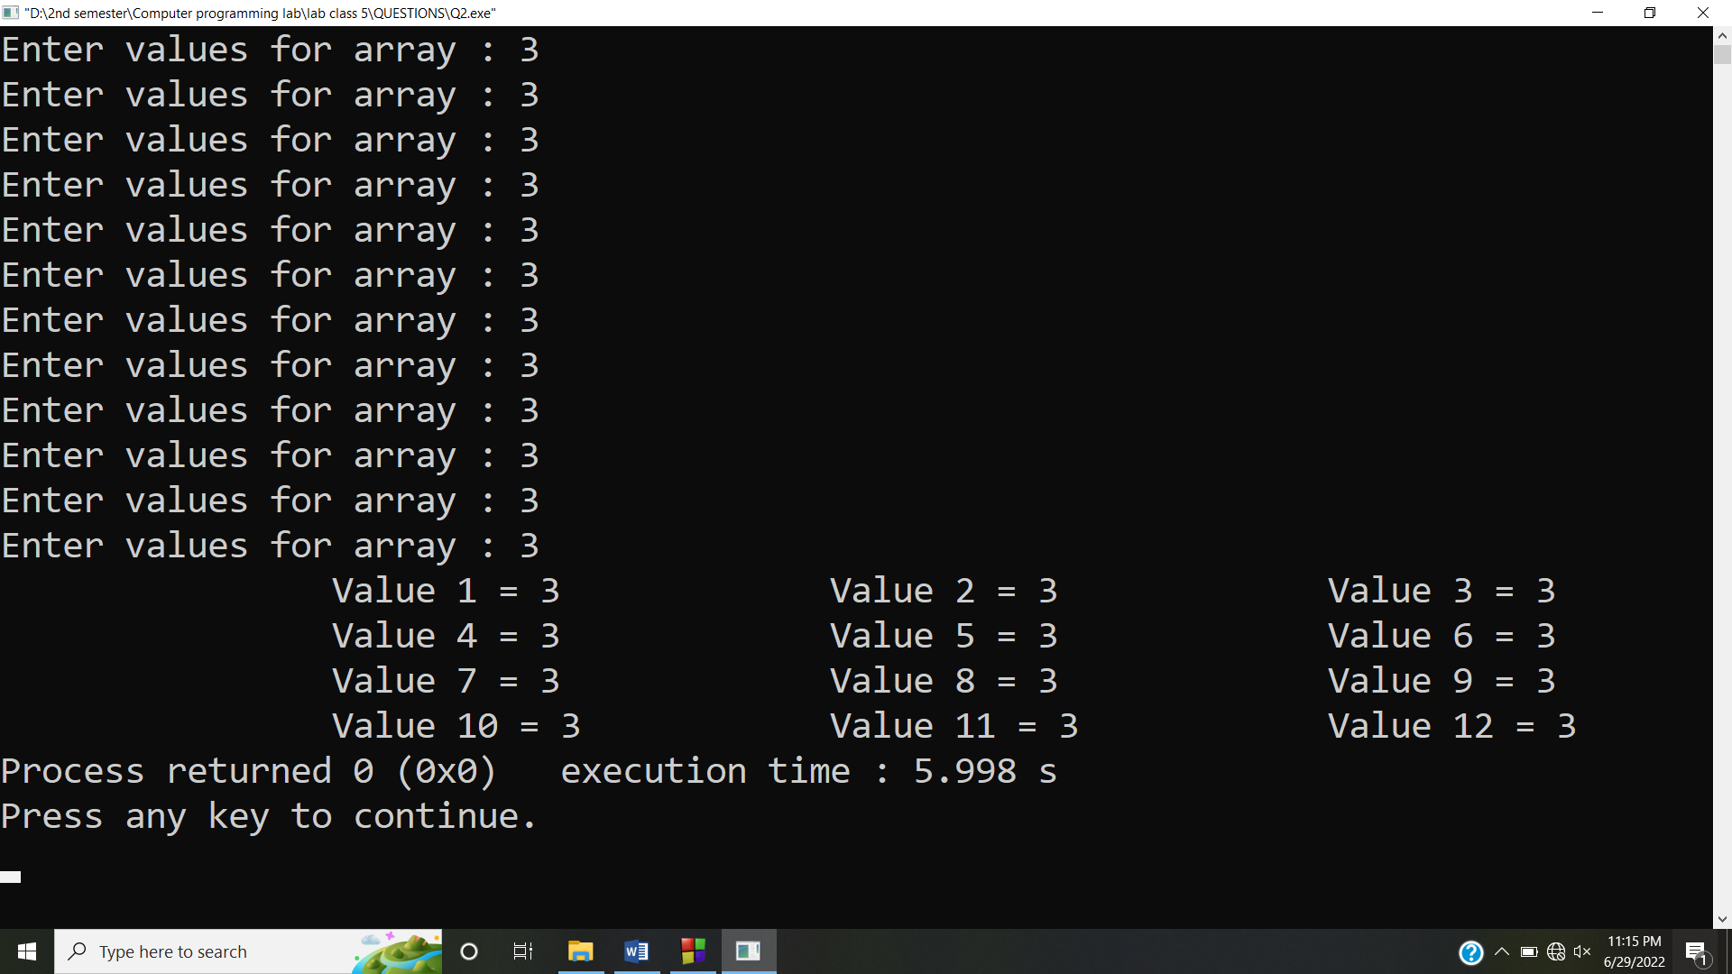

**Answer #3**

**CODE:**

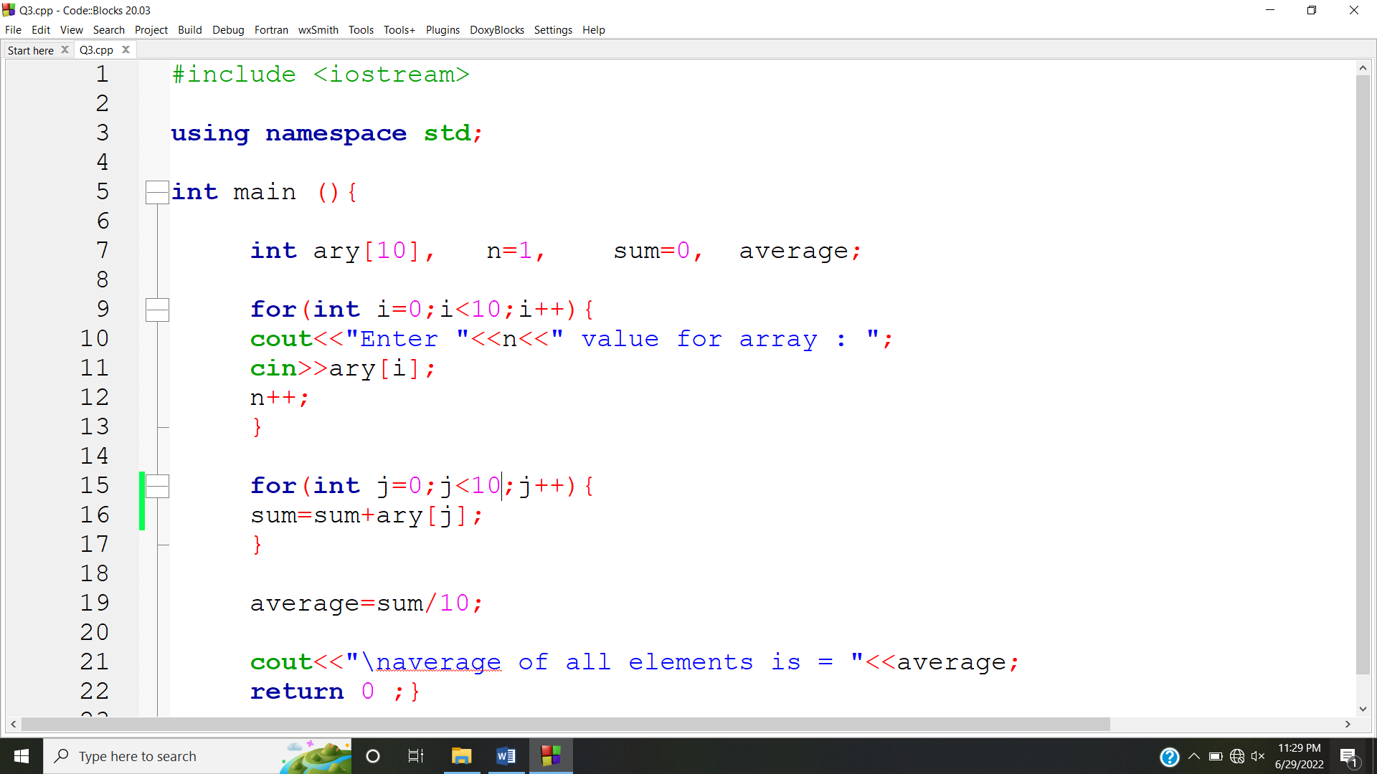

**OUTPUT:**

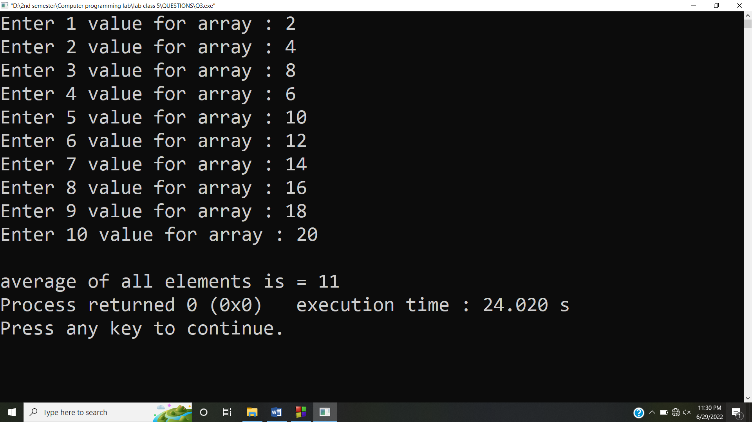

**Answer #4**

**CODE:**

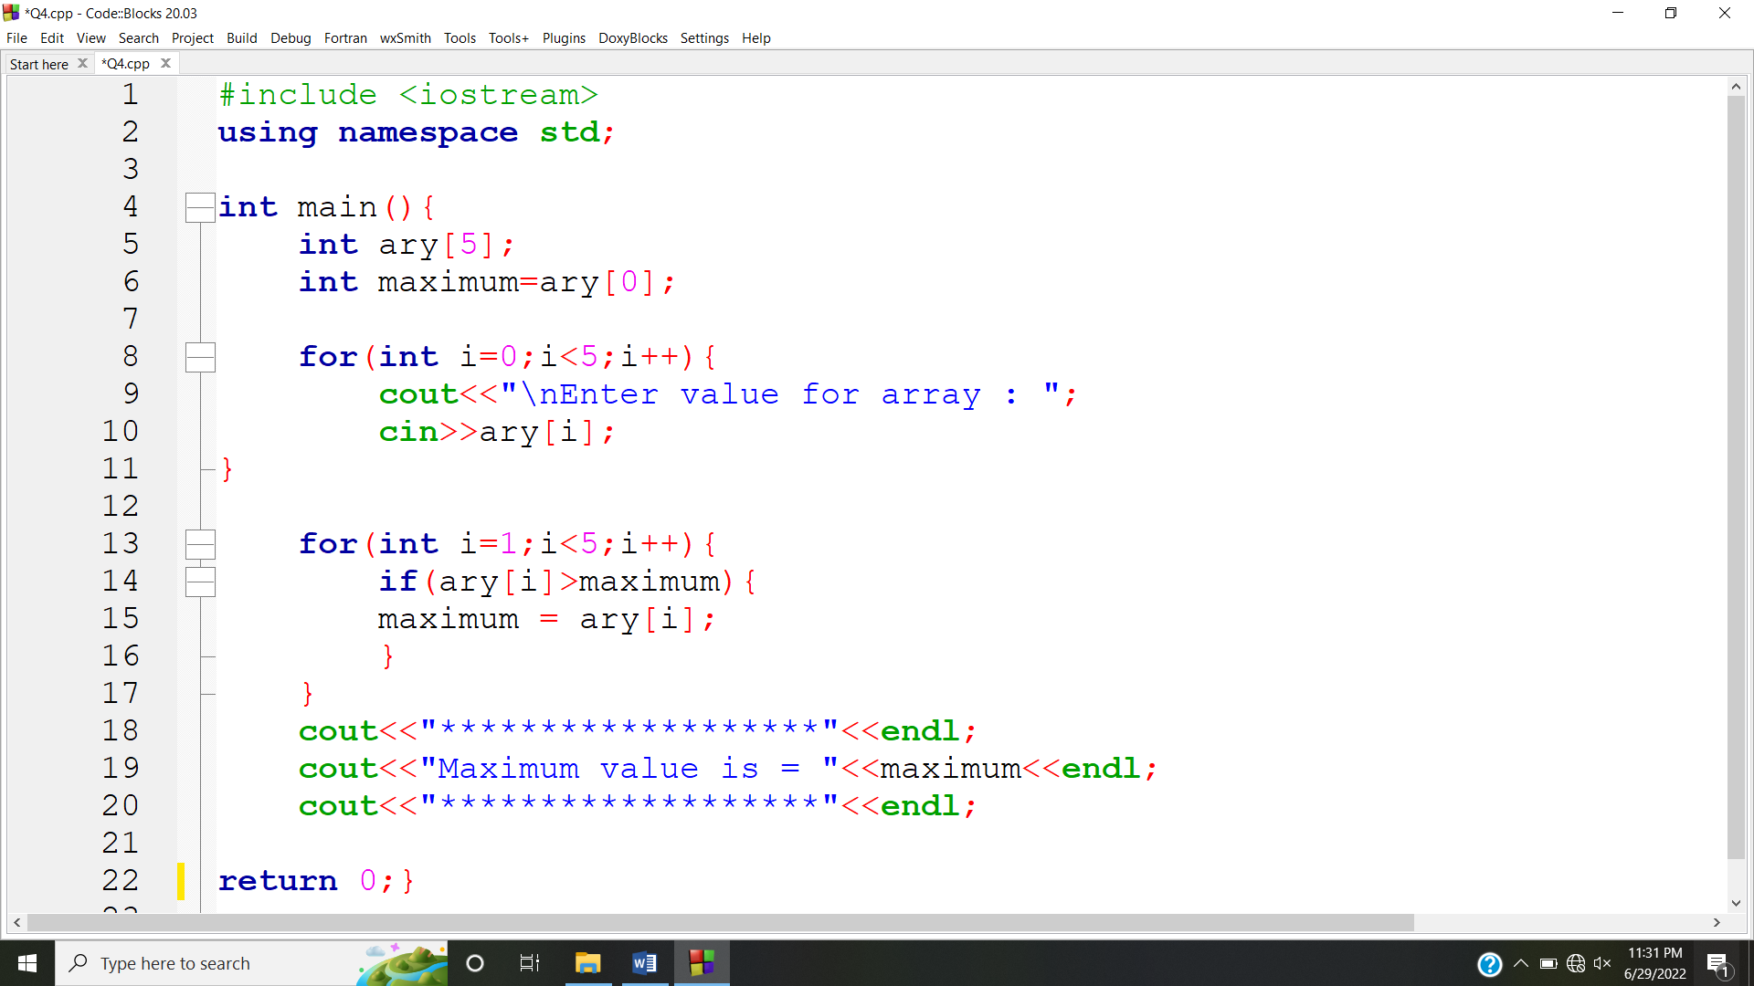

**OUTPUT:**

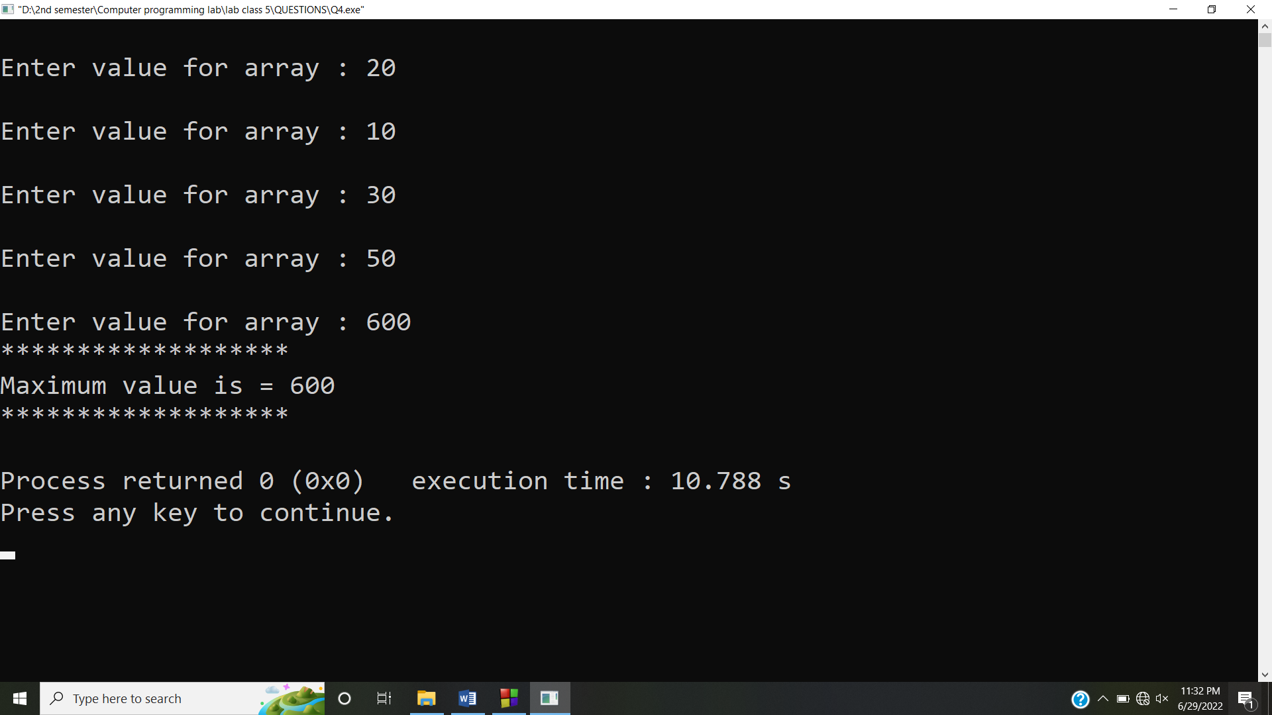

**Answer #5**

**CODE:**

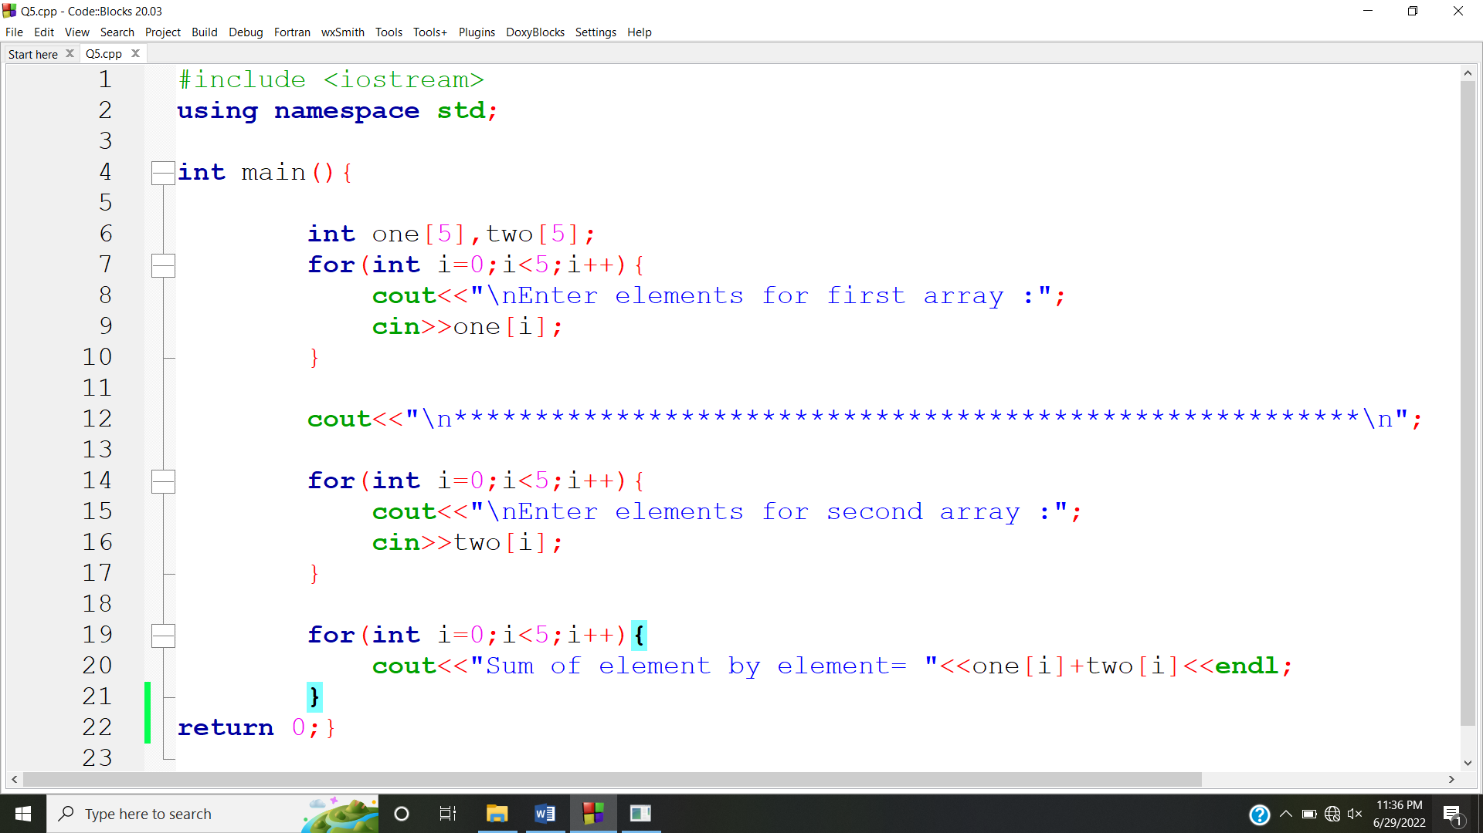

**OUTPUT:**

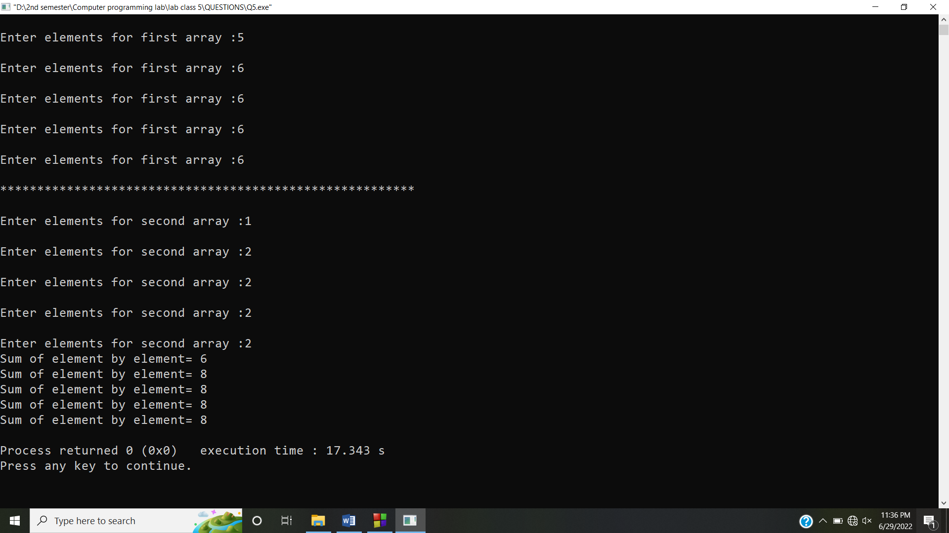

**Answer #6**

**CODE:**

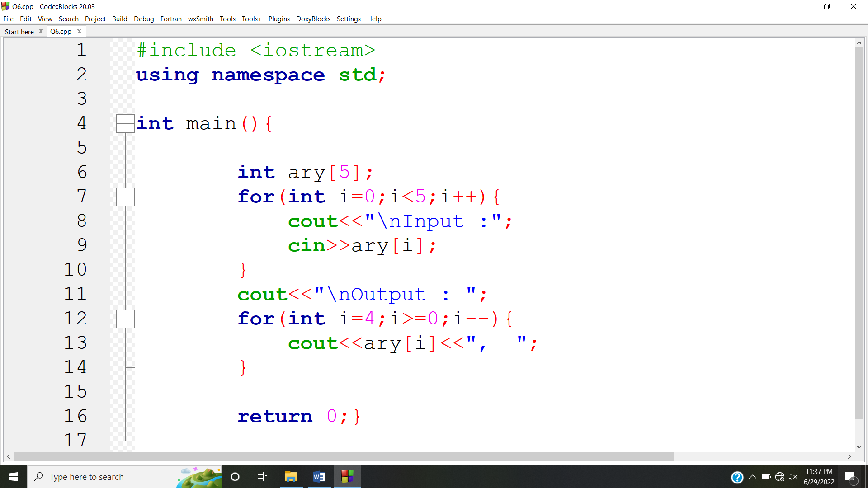

**OUTPUT:**

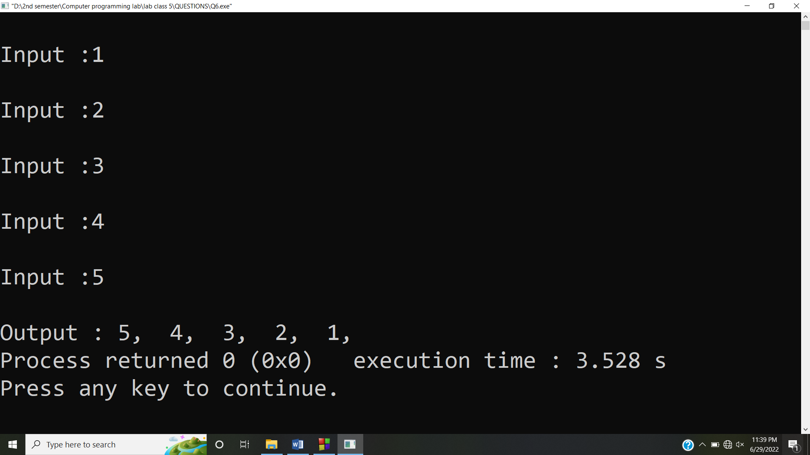

**Answer #7**

**CODE:**

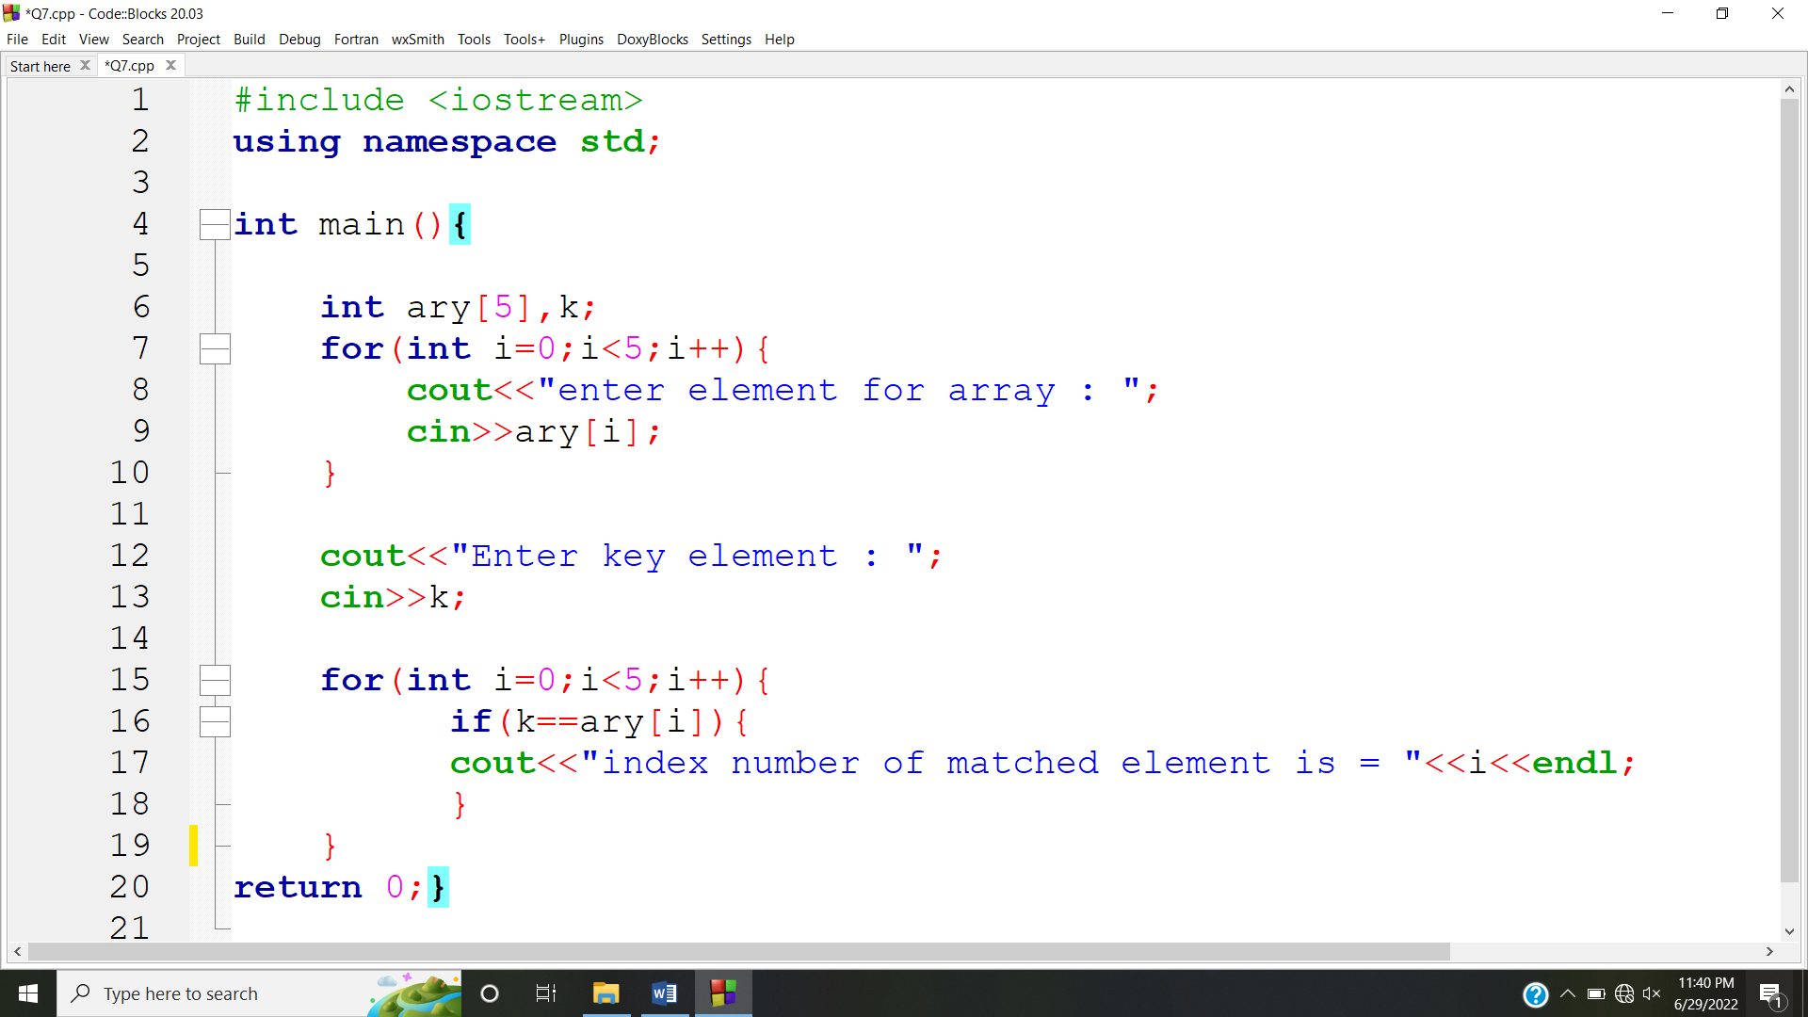

**OUTPUT:**

